Pin tool kit stuff

# As it were….

When in the Course of human events, it becomes necessary for one people to dissolve the technical systems which have connected them.

We hold these truths to be self-evident, that all Union Members are created equal and that we do not have a sufficient kit or training for our electrical connector servicing

This document details the electrical connector service tools that I have found around the shop or have identifies for the connectors we use. This list is not all encompassing and it is intended to be mutable.

### Description for crimping tools

ITT/Cannon, Veam model– this brand is a circular multi-conductor connector used extensively in T2 and 3 trains here at Tri-Met. This Veam connector line conforms to military spec XXXXX so it has a structured set of tooling standards.

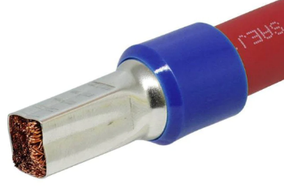Ferrules, ferrules are a conductor sleeve that is crimped in certain ways to accommodate certain connections. I have found this to be very industrial/automation centric.

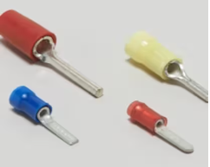TE connectivity/AMP generic PIDG!!! Pre-insulated diamond grip spade crimper is used extensively in T1 and on some places elsewhere in the fleet

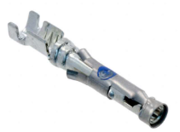TE Connectivity/AMP CPC connectors – These connectors are used extensively in the T1-3 fleet and in some places elsewhere like the TWC connections for the T4-5.

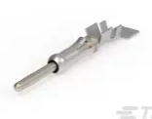Generic crimpers – a lot of terminals we use can be sufficiently crimped with a good quality set of generic W crimpers. There are several different sizes of crimps to be made in this area so it may not be surprising that there are 2-3 sets of crimpers we need to accomplish the range of crimps we have to do.

### Crimping tools

[Crimpin isn’t easy](https://www.te.com/commerce/DocumentDelivery/DDEController?Action=showdoc&DocId=Catalog+Section%7F6-1773984-5%7F2012%7Fpdf%7FEnglish%7FENG_CS_6-1773984-5_2012.pdf%7FN-A) a guide to modern crimping

1. DMC AF8 plus turrets - $500
   1. This one takes turrets and one generic pin stopper
   2. 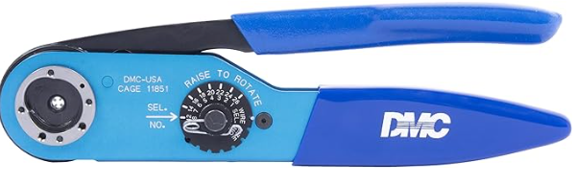
2. DMC AFM 8-smaller one - $450
   1. This one needs specific pin stoppers
   2. 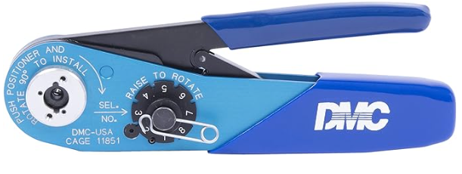
3. Good quality generic W shape crimping tool medium - $50-200
   1. 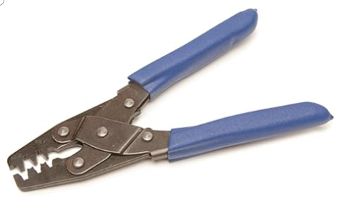
4. Good quality generic small W crimping tool $40 – 120
   1. <https://www.engineertools-jp.com/pa092021>
   2. 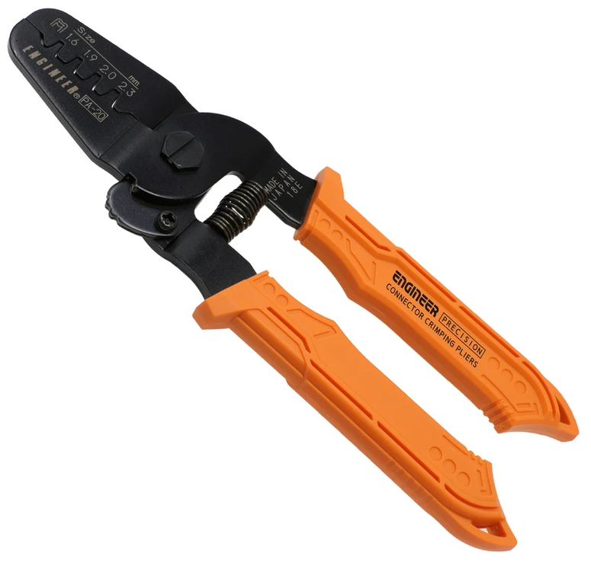
5. Knipex ferrule crimper [97 53 04](https://www.digikey.com/en/products/detail/knipex-tools-lp/97%252053%252004/10451678) $265.00
   * 1. 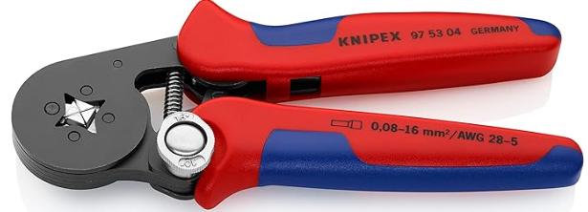
6. Rj45 crmper – klein [vdv226-011](a.%09https:/www.digikey.com/en/products/detail/klein-tools,-inc./VDV226-011-SEN/6804514) $50.00
   1. 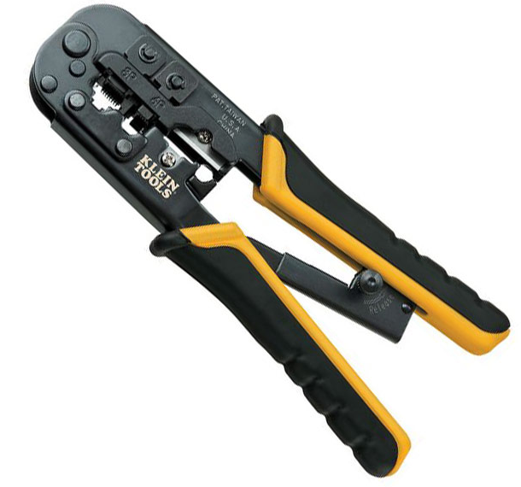
7. Coax crimpers
   1. Normal coax size
   2. <https://www.amphenolrf.com/tools/crimp-tools.html>
      1. 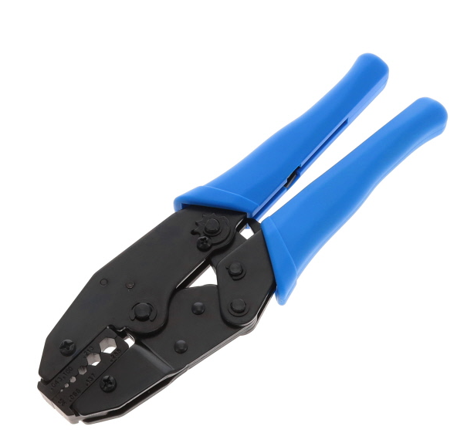
   3. Smaller coax size – see radio and APC wifi coax size.
8. Amp [– 59824-1](https://www.digikey.com/en/products/detail/te-application-tooling/59824-1/297746) PIDG terminal crimper $496.24
   1. 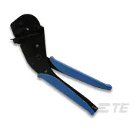
9. Amp/TE connectivity 47386 PIDG (pre-insulated diamond grip)crimper 16-26AWG $953.19
   1. This works on most generic PIDG terminals but maybe only the red class
   2. 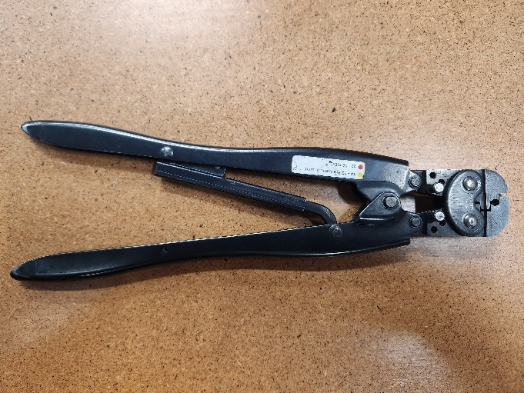
10. AMP/TE Connectivity 59239-4 12-10AWG yellow terminal $1386.09
    1. 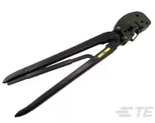
11. AMP/TE Connectivity 47387 20-14 AWG $919.91
    1. 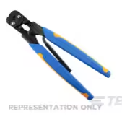
12. Snap on 29ACF $76.25
    1. 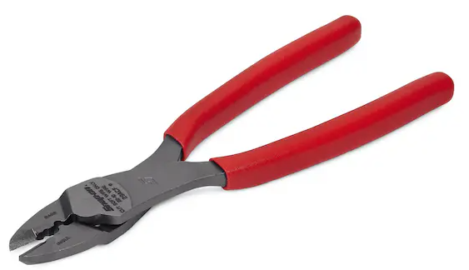
13. TE connectivity crimper body 354940-1 $132
    1. <https://www.digikey.com/en/products/detail/te-application-tooling/354940-1>
       1. This is a crimper with no jaws. The jaws are application specific
    2. 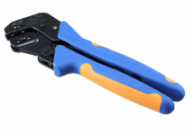
14. Harting 09990000620 $524.48
    1. 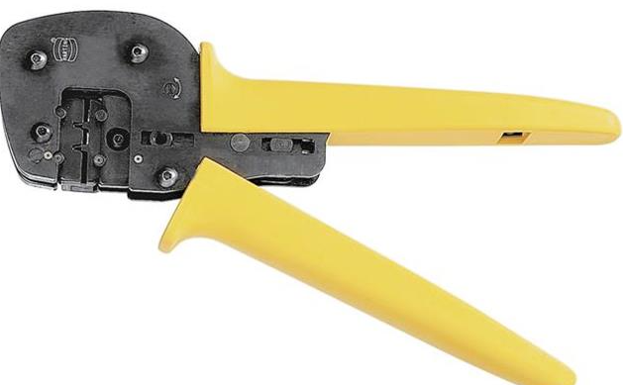
15. Knipex 97 53 08 $256.88
    1. 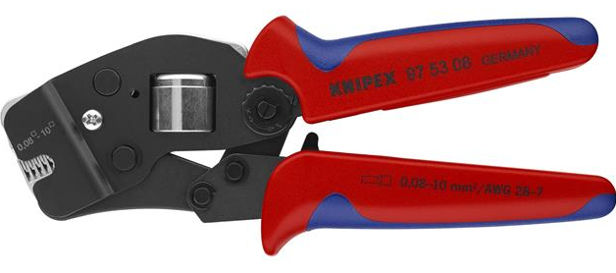
16. Knipex 97 68 145 A $40.00
    1. 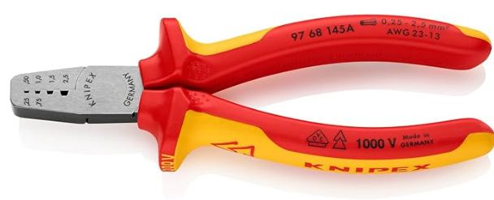

### Description for pin insertion/extraction tools

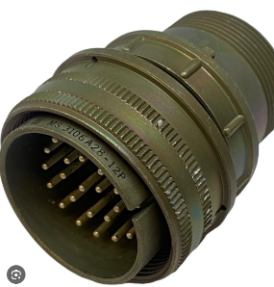Mils spec-

place words left pic right

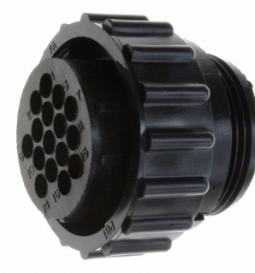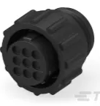TE connectivity/AMP CPC-

place words left pic right

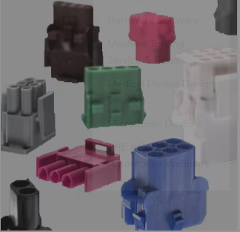TE connectivity mate-n-lok-

place words left pic right

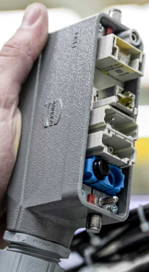

Harting HAN Modular-

place words left pic right

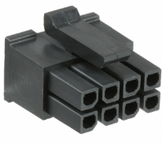Molex – various-

place words left pic right

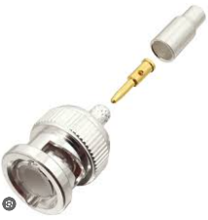Amphenol – bnc connectors



TE/ AMP PIDG

# Pin install/removal tools

### Mils spec/veam plugs

1. Veam A43240 $322.45
   1. [https://www.mouser.com/ProductDetail/ITT-Cannon/A43240](https://www.mouser.com/ProductDetail/ITT-Cannon/A43240%20$322)
   2. 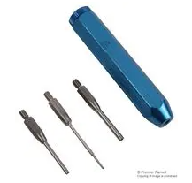
2. Veam 11-7576-37
3. Veam a43240-8
4. DMC pin tool pin 16 -$129
   1. <https://dmctools.com/drk82>
   2. 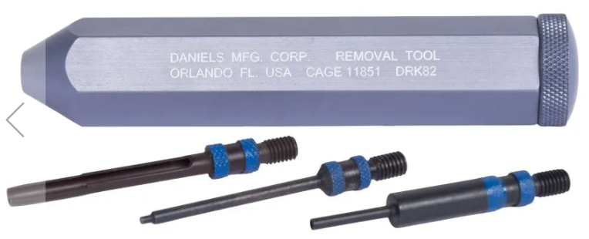
5. DMC pin tool pin 12 - $129
   1. <https://dmctools.com/drk80>
   2. 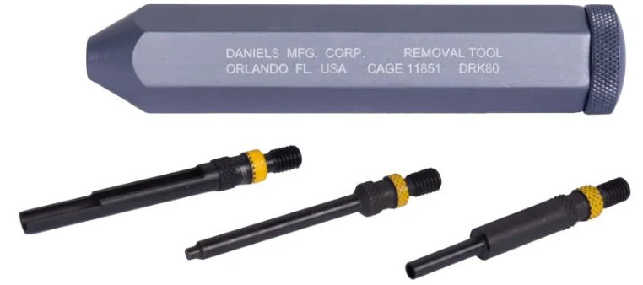
6. DMC pin tool Drk96 – $108.24
   1. <https://dmctools.com/drk96>
   2. 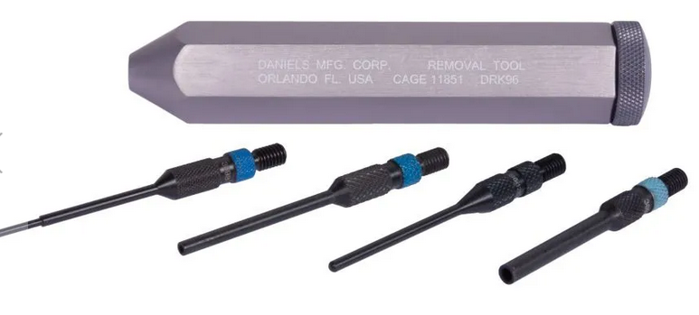
7. Jonard [tools Ka260](https://www.digikey.com/en/products/detail/jonard-tools/KA-260/610384) $175.00 insertion tools
   1. 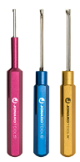
8. [Jonard KR260](https://www.digikey.com/en/products/detail/jonard-tools/KR-260/610385) $175.00 extraction
   1. 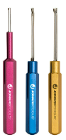

### Fine tip contact tools

1. [TE 91067-2](https://www.digikey.com/en/products/detail/te-connectivity-aerospace-defense-and-marine/91067-2/15557) $18.51
   1. 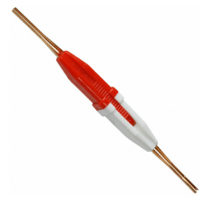
2. TE connectivity [91066-4](https://www.digikey.com/en/products/detail/te-connectivity-aerospace-defense-and-marine/91066-4/298281) $20.71
   1. 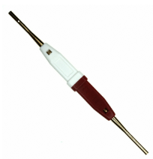
3. TE [91066-3](https://www.digikey.com/en/products/detail/te-connectivity-aerospace-defense-and-marine/91066-3/298280) $20.91
   1. 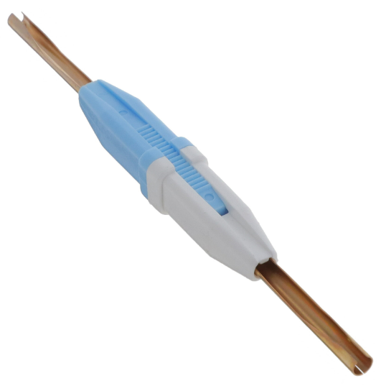
4. TE [91067-1](https://www.digikey.com/en/products/detail/te-connectivity-aerospace-defense-and-marine/91067-1/207259) $18.20
   1. 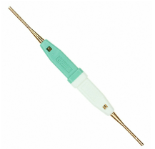
5. TE connectivity [1643915-1](https://www.digikey.com/en/products/detail/te-connectivity-amp-connectors/1643915-1/1636374)  plastic body $5.23
   1. 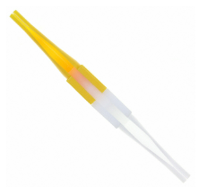
6. Astro tool corp [M81969/14-03](https://www.digikey.com/en/products/detail/astro-tool-corp/M81969-14-03/4951912) pin size 16 $2.65
   1. 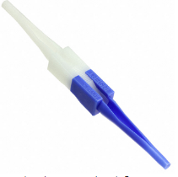
7. Astro tool corp [M81969/14-04](https://www.digikey.com/en/products/detail/astro-tool-corp/M81969-14-04/4951913) $2.65
   1. 

Guide pins DMC

1. 27977-16T50 #16 pin size
   1. <https://www.mouser.com/ProductDetail/ITT-Cannon/27977-16T50> $7.10
2. 27977-12T50 #12 pin size

### Harting plugs

1. Han D plug Pin puller tool 09990000328 $112.00
   1. 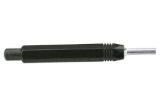
2. Pin puller tool HAN E 09 99000 0319 $40.00
   1. 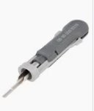
3. 09 99 000 0305 $20.00
   1. 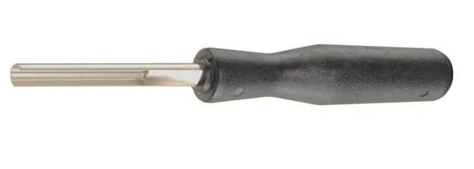
4. 0999 000 0315 $75.00
   1. 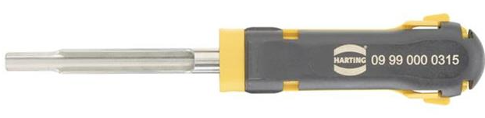
5. 09 99 00 0052 $15.04
   1. 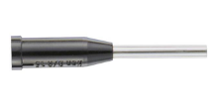
6. HAN d removal tool? 09990000012 $63.04
   1. 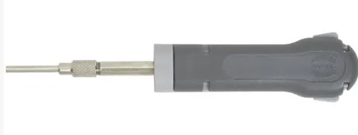
7. socket puller 09 99 000 0828 $179.00
   1. 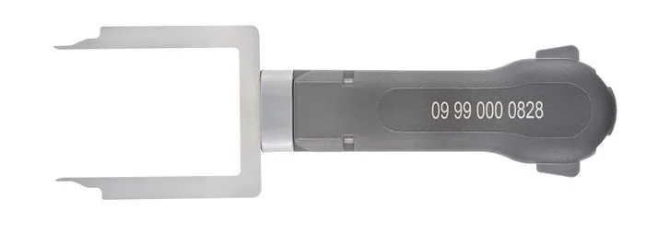
8. Sub D HAN contact removal tool 09990000368 $28.25
   1. <https://www.digikey.com/en/products/detail/harting/09990000368/3181508>
   2. 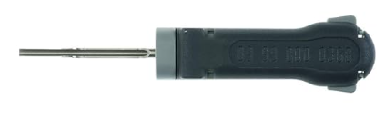

## Molex plugs

1. [mini fit jr pin remover 11-03-0044](a.%09https:/www.digikey.com/en/products/detail/molex/0011030044/210947) $28.54
   1. 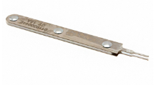
2. [Mini fit JRready tool](a.%09https:/www.jrdtools.com/products/jrready-dap-d173-mini-fit-jr-extraction-tool-molex-11-03-0044-for-mini-fit-jr-tm-series-terminals-30490-44476-44478-5556t-t2-t3-and-5558t) $25.00
   1. 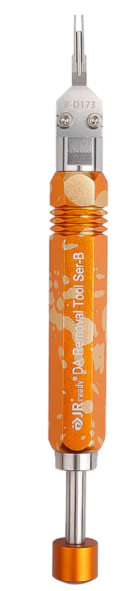
3. [0.093 terminal Molex 0011030006](https://www.digikey.com/en/products/detail/molex/0011030006/228692) $28.54
   1. 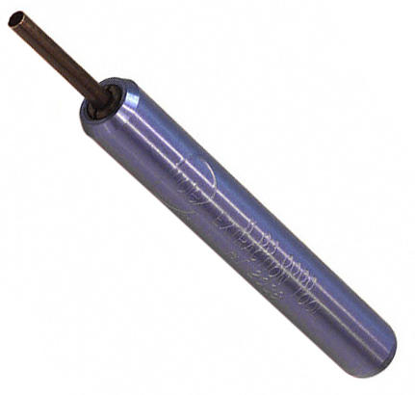
4. [0.062 Terminal Molex](a.%09https:/www.digikey.com/en/products/detail/molex/0011030002/228689) $24.96
   1. 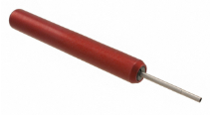
5. TE Connectivity/AMP D-sub?
   1. TE-91285-1 $ 40.00
      1. 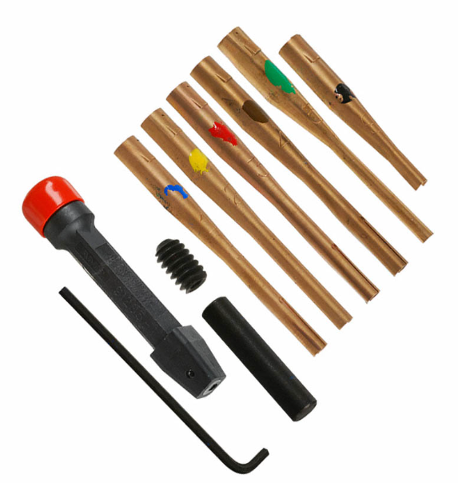

### TE Connectivity Mate-n-lok

1. <https://www.te.com/usa-en/product-465644-1.html> $42.00
   1. 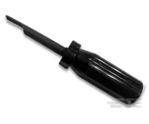
2. [https://www.digikey.com/en/products/detail/te-application-tooling/465644-1/15682](https://www.digikey.com/en/products/detail/te-application-tooling/465644-1/15682%2039.00) $39.00
   1. 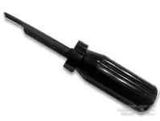
3. <https://www.digikey.com/en/products/detail/te-application-tooling/1-305183-1/1990885> $279.00
   1. 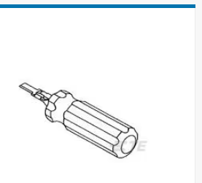
4. TE connectivity Mate-N-Lok extract 1-305183-1 $279.00
   1. 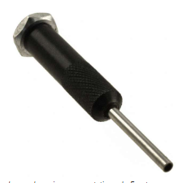
5. TE Connectivity mate-n-lok socket extract $81.18
   1. 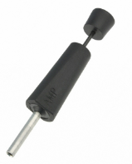

### TE Connectivity/AMP CPC (circular plastic connector)

1. removal tools TE-305183 $17.46
   1. <https://www.digikey.com/en/products/detail/te-application-tooling/305183/15640>
      1. 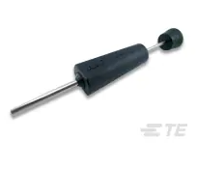
2. Removal tool TE 2063388-1 $19.00
   1. <https://www.te.com/usa-en/product-2063388-1.html> 19.00
      1. 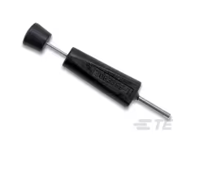
3. Insertion extraction 91285-1 $40.00
   1. <https://www.te.com/usa-en/product-91285-1.html> $39.00
   2. <https://www.digikey.com/en/products/detail/te-application-tooling/91285-1/132443> $33.00
      1. 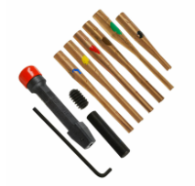
4. TE connectivity [9-1579007-1](https://www.digikey.com/en/products/detail/te-application-tooling/9-1579007-1/2053544) $65.00
   1. 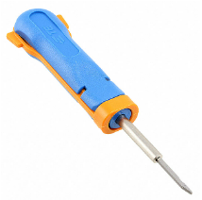

## Plastic contact tools

1. TE Connectivity [114010](https://www.digikey.com/en/products/detail/te-application-tooling/114010-ZZ/6566678) ~$2.00
   1. 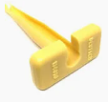
2. TE Connectivity [0411-337-1205](https://www.digikey.com/en/products/detail/te-application-tooling/0411-337-1205/9477715)  ~$2.00 EA
   1. 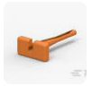
3. TE Connectivity [0411-204-1605](a.%09https:/www.digikey.com/en/products/detail/te-application-tooling/0411-204-1605/6566672) ~$2.00 EA
   1. 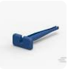
4. TE Connectivity [0411-291-1405](a.%09https:/www.digikey.com/en/products/detail/te-application-tooling/0411-291-1405/6566674) ~$2.00 EA
   1. 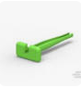
5. TE Connectivity [0411-310-1605](https://www.digikey.com/en/products/detail/te-application-tooling/0411-310-1605/9477714)  ~$2.00 EA
   1. 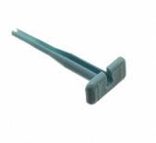
6. TE Connectivity [0411-336-1605](https://www.digikey.com/en/products/detail/te-application-tooling/0411-336-1605/6566673)  ~$2.00 EA
   1. 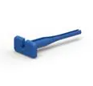
7. TE Connectivity [0411-240-2005](a.%09https:/www.digikey.com/en/products/detail/te-application-tooling/0411-240-2005/6566676)  ~$2.00 EA
   1. 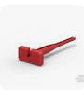
8. TE Connectivity [0411-354-1605](https://www.digikey.com/en/products/detail/te-application-tooling/0411-354-1605/9477716) ~$3.50 EA
   1. 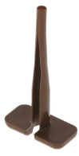
9. Amphenol sine [AT11-337-1205](https://www.digikey.com/en/products/detail/amphenol-sine-systems-corp/AT11-337-1205/14011232) $1.44
   1. 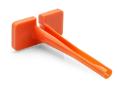

### Pin install plyers

1. Veam install plyers $100.00 11-7345 size 16 pin
   1. <https://www.mouser.com/ProductDetail/ITT-Cannon/11-7345>
   2. 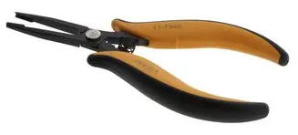
2. Veam install plyers p46736 size 12 pin
   1. <https://www.newark.com/veam/46736/insertion-tool-size-12-contact/dp/51M8181> $245
   2. 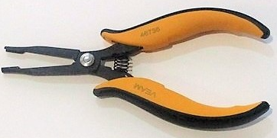
3. DMC install plyers DAK-168-16 pin size 16
   1. <https://dmctools.com/dak489> 340.13
   2. 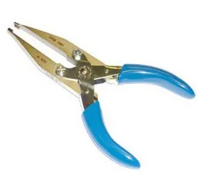
4. DMC install pliars DAK168-12 pin size 12
   1. <https://dmctools.com/dak168-12> $332.34
   2. 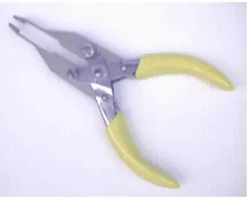
5. TE connectivity [91002-1](https://www.digikey.com/en/products/detail/te-connectivity-amp-connectors/91002-1/29746)   
   TOOL INSERTION .062 & .093 CONN
   1. 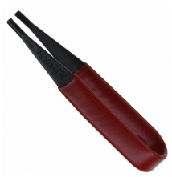

## The great unknown – why we need generic pin tools.

Jr ready kits for unknown and unexpected situations. Add purchase links

1. Jready st5211 $22.00
   1. 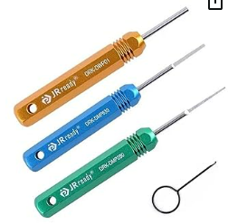
2. Jready st 5252 $40.00
   1. 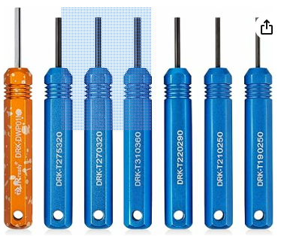
3. Jready st5236 $50.00
   1. 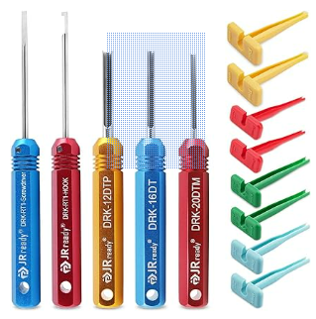
4. Jready st 5227 $50.00
   1. 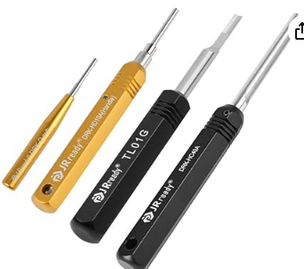

### Wire stripping tools

1. Ideal brand stripmaster
   1. Goto site to find which one you want!
   2. 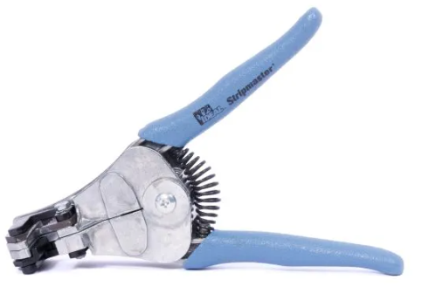
   3. <https://www.idealind.com/us/en/shop/product-type/aerospace/stripmasterr.html>
   4. 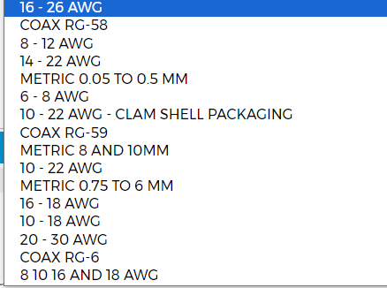
2. Various gauged strippers
   1. Expand and specify
   2. 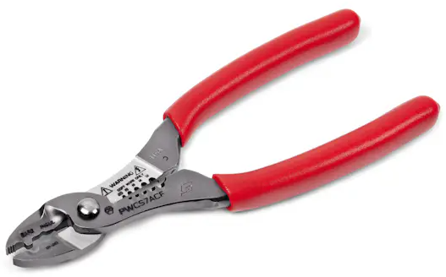
3. Coax stripping tools
   1. Ideal 2 blade adjustable 45-526 1/4 in. strip between blades
      1. 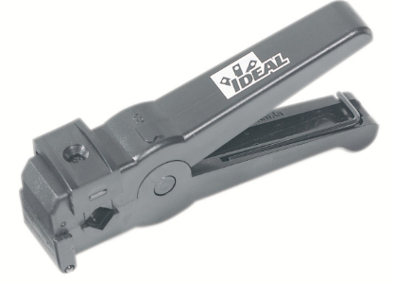
   2. Ideal3 blade adjustable 45-520
      1. 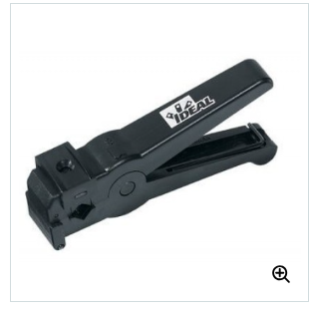
   3. Ideal 45-605
      1. 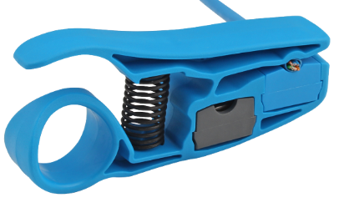
   4. Ideal 45-165
      1. .240”/6.1mm blade spacing, strips from  from .187”/4.8mm up to .313”/8mm in diameter
      2. 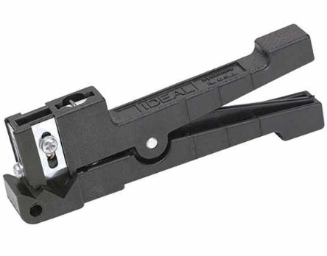
   5. Ideal 45-162
      1. 240”/6.1mm blade spacing, Strips up to .125”/3.2mm in diameter
      2. 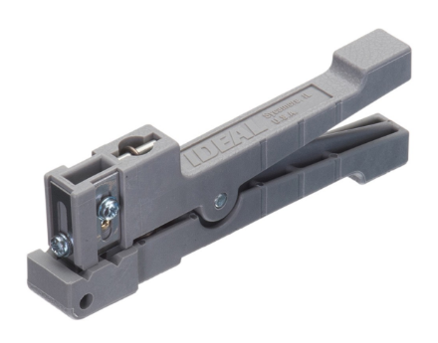
   6. Ideal 45-164
      1. .560”/14.22mm blade spacing, Strips from .250”/6.4mm up to .563”/14.3mm in diameter
      2. 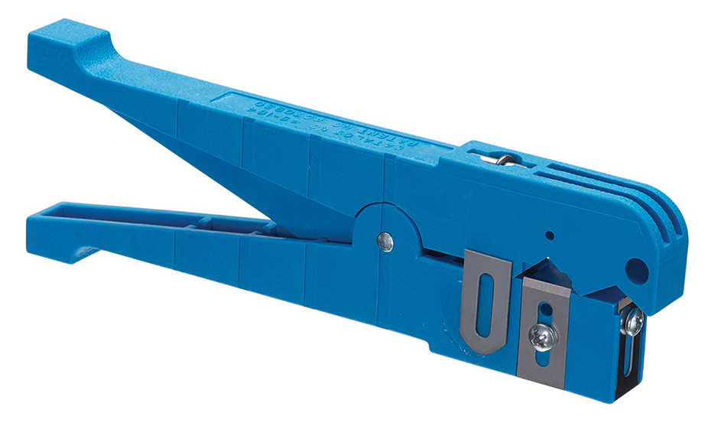
   7. Ideal 45-163
      1. .240”/6.1mm blade spacing, Strips from .125”/3.2mm up to .250”/6.4mm in diameter
      2. 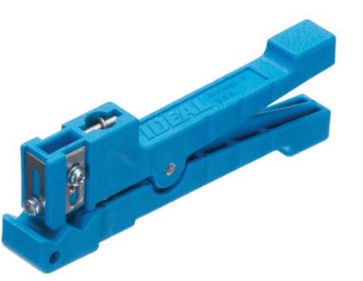

# Bonus round!!!

### Cannon plug plyers.

1. Snap-on [AT1508KG](https://b2b.snapon.com/productDetails/859738/2/882280) $45.05
   1. 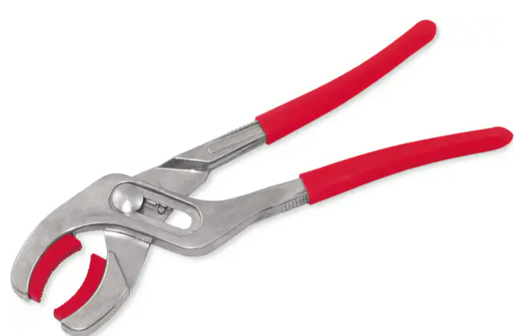
2. Snap-on [pwc53](https://b2b.snapon.com/productDetails/954287/2/882280) $93.00
   1. 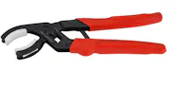
3. Snap-on [pwc5330](https://b2b.snapon.com/productDetails/954295/2/882280) $93.00
   1. 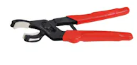
4. Blue point [PWC52A](https://shop.snapon.com/product/Miscellaneous/Connector-Pliers-(Blue-Point)/PWC52A) $66.00
   1. 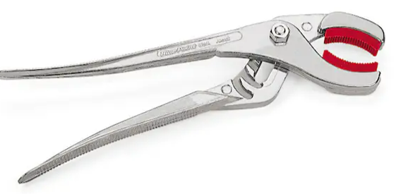
5. Daniels 30 degree head [BT-SJ-509A](https://dmctools.com/bt-sj-509a) $87.00 – same as Snap-On?
   1. 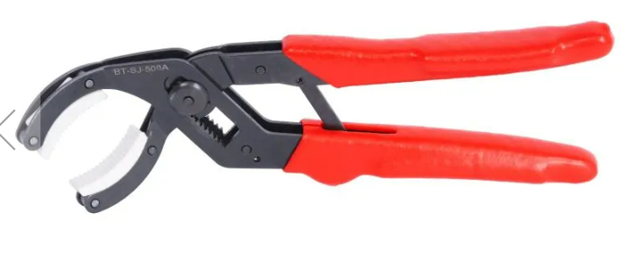
6. Daniels straight head [BT-SJ-509R](https://dmctools.com/mini-soft-jaw-pliers-straight-head) $84.21 same as Snap-On?
   1. 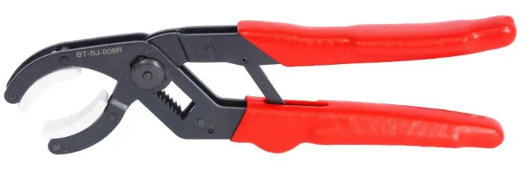
7. Knipex 81 11 250 $44.00 ish – [amazon?](https://www.amazon.com/KNIPEX-Gripping-Replaceable-Plastic-8111250/dp/B01I20T9I8?th=1)
   1. 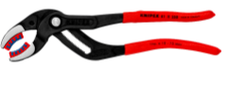
8. Knipex 81 01 250 $35.35
   1. 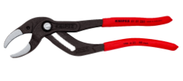
9. Stanley J253G $33.86 amazon
   1. 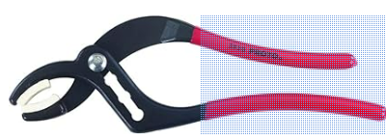
10. SK tools 7625 $75.00 amazon
    1. 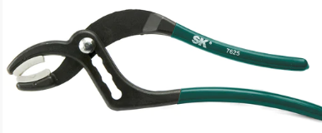

# Terminal activation tools

1. Pheonx contact [1200135](https://www.digikey.com/en/products/detail/phoenix-contact/1200135/6163337) $24.00
   1. 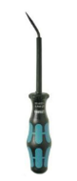
2. Wago [210-719](https://www.digikey.com/en/products/detail/wago-corporation/210-719/13549325) BLADE: 2.5 X 0.4 $10.00
   1. 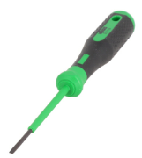
3. Wago [210-720](https://www.digikey.com/en/products/detail/wago-corporation/210-720/13549418) BLADE: 3.5 X 0.5 $11.00
   1. 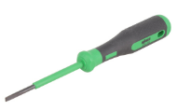
4. Wago [210-721](https://www.digikey.com/en/products/detail/wago-corporation/210-721/13549313)BLADE: 5.5 X 0.8 $18.15
   1. 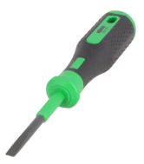
5. Wago [210-722](https://www.digikey.com/en/products/detail/wago-corporation/210-722/13549336) tool set $36.47
   1. 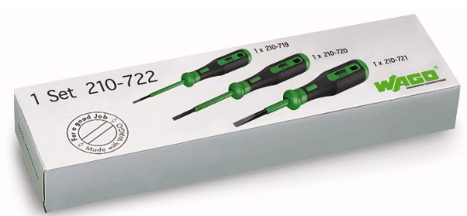
6. Wago [210-658](https://www.digikey.com/en/products/detail/wago-corporation/210-658/13549492) BLADE: 3.5 X 0.5 $11.00
   1. 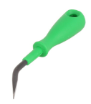
7. Wago [210-648](https://www.digikey.com/en/products/detail/wago-corporation/210-648/13549391)   BLADE: 2.5 X 0.4 $11.00
   1. 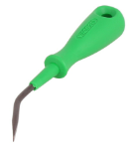
8. Wago [210-657](https://www.digikey.com/en/products/detail/wago-corporation/210-657/13549332) BLADE: 3.5 X 0.5 $10.00
   1. 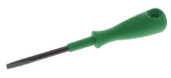

### Terminal retention TTP’s

(tips, tool and procedures)

I thank we need to maintain tooling and education to examine pin tension when troubleshooting and servicing.